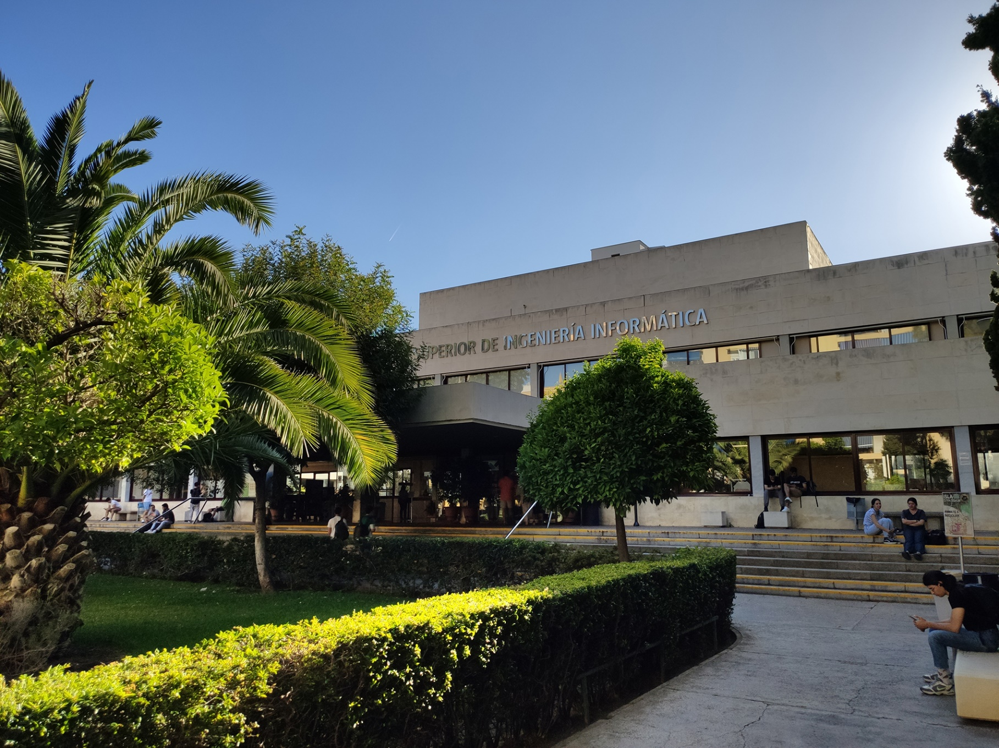

|  |
| --- |
| Planning Report |
| Jesús Cárdenas Conejo  (jescarcon@alum.us.es) |
| 17-02-2023  Group: C1.02.10  Repository: https://github.com/jescarcon/Acme-L3-D01-23.1 |



Table of Contents

Executive Summary 3

Version History 4

Introduction 5

Contents 6

Conclusions 7

Bibliography 8

# Executive Summary

In this document i will introduce how were divided my tasks of the project. I used a table to do it , with relevant content of the task.

# Version History

|  |  |  |
| --- | --- | --- |
| Version | Date | Description of changes |
| V1.0 | 16/02/2023 | Creation of the Planning Report and completion |

# Introduction

In this document I will describe how I plan my student’s individual tasks, you will find a table that represent the planning with 6 colums, one for the title of the task, one for the description of the task, one for who is assignated to the manner, as it is my individual report I am the one in charge of all the tasks, another colum for the planned time, time that I stimated to spend doing the task then a colum is for the actual time that I spend doing the chore, and finally the price asociated to the task . I use the rule for declaring the cost as 30€/h for the Manager/Analyst tasks and 20€/h for the developer ones.

# Contents

This table represents all the individual task that were asignated to me, for each one I provide a title, a description, the asignee in this case myself, the planned time and the actual time that I used reaching making the requirement and the cost associated.

|  |  |  |  |  |  |
| --- | --- | --- | --- | --- | --- |
| Title | Succinct Description | Assignee/s and Role/s | Planned Time | Actual Time | Cost |
| Functional requirements #1 | Modify the anonymous menu so that it shows an option that takes the browser to the home page of your favourite web site. The title must read as follows: “〈id-number〉: 〈surname〉, 〈name〉”, where “〈id-number〉” denotes your DNI, NIE, or passport number, “〈surname〉” denotes your sur-name/s, and “〈name〉” denotes your name/s. | Jesús Cárdenas Conejo | 10’ | 5’ | 1,6€(developer) |
| Analysis Report | Create Analysis Report | Jesús Cárdenas Conejo | 30’ | 20’ | 10€(analyst) |
| Planning Report | Create Planning Report | Jesús Cárdenas Conejo | 30’ | 10’ | 5€(analyst) |

I also put them on GitHub to a better follow:

# Conclusions

This first requirements are so simple because I’m just starting the project, I did it fast and that gives me knowledge of how the structure of the project is, that will help in the future requirement develop.

# Bibliography

Intentionally blank.